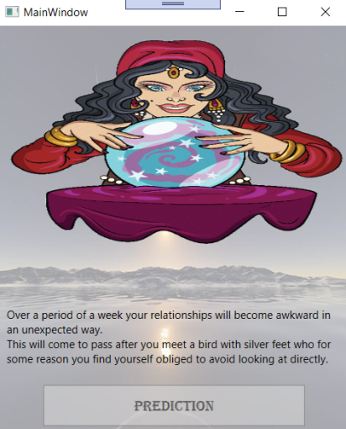**Array Exercise 1 - Fortune Predictor**

Let’s look at some examples of using arrays.

First make a new project called ***Predictor***, then……

Create an array of strings called ***timeArray*** with the following data:

* thirty minutes
* an hour
* eight hours
* twelve hours
* a day
* a week
* a month
* a year
* a decade

Create an array of strings called ***aspectArray*** with the following data:

* finances
* love life
* career prospects
* travel plans
* relationships

Create an array of strings called ***effectArray*** with the following data:

* fall apart
* exceed your expectation
* become awkward in an unexpected way
* become manageable
* become spectacular
* come to a positive outcome

Create an array of strings called ***personaArray*** with the following data:

* man
* boy
* woman
* girl
* dog
* bird
* hedgehog
* singer
* relative

Create an array of strings called ***featureArray*** with the following data:

* pink hair
* a broken golden chain
* scary eyes
* long blond nose hair
* very red lips
* silver feet

Create an array of strings called ***consequenceArray*** with the following data:

* avoid looking at directly
* sing a sad song with
* stop and talk to
* dance with
* tell a secret
* buy a coffee

Create a Button click event and a TextBlock for output.

In the click event use a random number to select an element randomly from each of the strings, as the following example illustrates ***timeArray[number.Next(0, timeArray.Length)].***

In the click event, add the arrays to the following string to build a basic fortune predictor (use the TextBlock to output the string):

Over a period of ***timeArray*** your ***aspectArray*** will ***effectArray***.

This will come to pass after you meet a ***personaArray*** with ***featureArray*** who for some reason you find yourself obliged to ***consequenceArray***.

Use the TextBlock string to also output the prediction as a text-to-talk message.

Now add an image to your application.



***Finally***… change the message and the content of the arrays to develop your own version of the application…